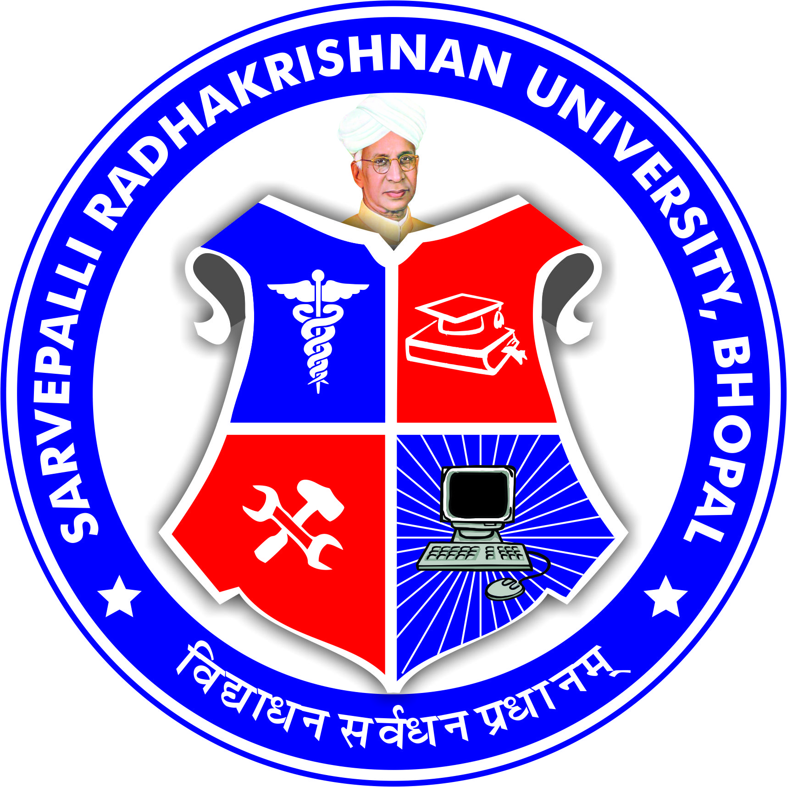
SARVEPALLI RADHAKRISHNAN UNIVERSITY
NH 12, HOSHANGABAD ROAD, JATKHEDI, BHOPAL (M.P.)
¼Established under M.P.Niji V.V. (Sthapna avam Sanchalan) dwitiya Sansodhan Adhiniyam,2014½

Research Advisory Committee
The Research Advisory Committee (RAC) of Sarvepalli Radhakrishnan University, Bhopal (M.P.) is reconstituted as per UGC Guidelines for the effective and robust Research Governance.
S.No. | NAME OF THE MEMBER | REMARKS
1 | Dr. Priyanka Jaiswal  Vice Chancellor | Chair Person
2 | Dr. S.S. Pawar  Registrar | Member
3 | Dr. Rajneesh Karn  Dean Research | Member
4 | Dr. Pratyush Jain  Dean Faculty of Pharmacy | Member
5 | Dr. M.C. Prashant  Dean Faculty of Dentistry | Member
6 | Dr. Richa Gupta  Dean Faculty of Allied Sciences | Member
7 | Dr. A. K. Shrivastav  Dean Faculty of Medicine | Member
8 | Dr. Archana Selvan  Dean Faculty of Nursing | Member
9 | Dr. Sushil Singh  Dean Faculty of Management | Member
10 | Dr. Varsha Namdeo  Dean Faculty of Computer Application | Member
11 | Dr. Devendra Kumar Dhote  Dean Faculty of Ayush | Member

The Powers and Functions of the RAC are as under :-
- The Committee shall follow the guidelines for establishment of the Research and Development Cell (RDC) as per the norms of the UGC.
- The Committee shall meet at least thrice in an academic year. A majority (2/3rd) of the members must be present to constitute a quorum.
- Support and monitor research and development activities in the University and submit the detailed report to Academic council on the progress of the research activities.
- Invites research institutions, industries and identifies individuals and departments/centers of University for collaborations in mutual understanding.
- Reviews, monitors, and guides the Special Interest Group(SIG) of University.
- Promotes and recommends the submission of scientific research proposal/projects to various funding agencies.
- To support the scientific research publications for publication in the reputed journals as per the guidelines of the University.

sd-
Registrar

